# IU Verse

It is like porn. You will know if you squeezed one.

* [YKIYK](https://x.com/govtimwalz/status/1903511215764066588?s=46)

When life gives you tangerine

* [The children are our future](https://m.facebook.com/groups/441825848138419/permalink/960751552912510/?mibextid=wwXIfr)

Louisa just had a baby. Yeh! Congratulations.

* [Congratulations](https://m.facebook.com/story.php?story_fbid=pfbid025yjitMxRHmbF91fw3mjF13aG4tT2bXa9r12A45NmVv8KkX3UoU5MCjSDb8B3W747l&id=100044313015382&mibextid=wwXIfr). Say, what is her/his name?

# Minecraft

* [A Minecraft Movie – Minecraft Wiki](https://minecraft.fandom.com/wiki/A_Minecraft_Movie)
* [Jack Black is back!](https://www.msn.com/en-us/movies/news/a-minecraft-movie-behind-the-scenes-clip-jack-black-jason-momoa/vi-AA1ujpfv?ocid=socialshare)

# Lewis Howes

Plastering posters for Lewis Howes for his book tour happening in a few hours!!

* [Book tour!!](https://www.youtube.com/watch?v=C3fEigVlkMc)

Rosé

* [Drinking](https://x.com/roseannepics/status/1903773234434068563)

# Shawn Carolan

Early investor in Uber is Shawn Carolan.

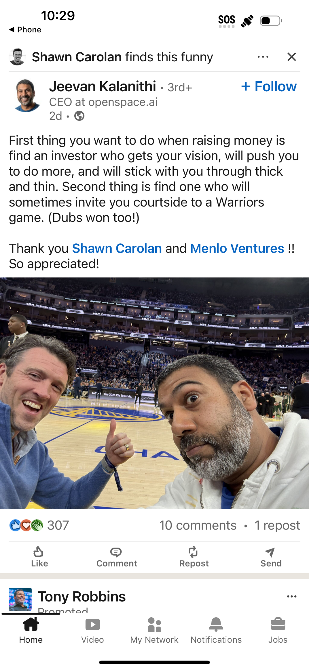

# Email Sender

@ethan_kross from Chris Williamson

# Andrew Schultz

* [Keeping the marriage alive](https://x.com/andrewschulz/status/1902178956415025176)

# Parral Virtual Machine

Ok, I’ve gotten the PVM to work in my Nortel days. I will start working on it.

* [OS for Quantum computers](https://www.msn.com/en-us/news/technology/qnodeos-claims-to-be-the-first-operating-system-for-quantum-networks-paving-the-way-for-future-quantum-applications/ar-AA1ARnCc?ocid=msedgdhp&pc=DCTS&cvid=98abb012a99142829921de7b8d47fa2f&ei=42)

# Label Algebra

View Master side:

**Label Algebra** document is located in $PTD/docs

Label Algebra

Summary

This document describes the technical layout of Label Algebra. This new technology allows the user to interactively enter data with its attached label for ease of input and output exchange.

History:

In 1996 while finishing up my undergraduate classes in UC Davis majoring in Computer Science Engineering, I picked up HTML and Java programming. That was when Java just came out, and Sun Microsystems was launching a series of online competition to heat up the lure of Java. I submitted an Applet that uses the concept of **Label Algebra** to allow user input for simple algebraic equations. Since Applet allows user to parametrize Applets, Label Algebra turned out to be useful and versatile. The whole concept of doing business on the internet was picking up stream, so **Label Algebra** was a logical step in creating Apps for the browser. I called the Applet “Abacus”.

My friend asked me to submit a resume to work as internship in Symantec all while waiting for the result of my Jars competition. Eventually I made it to the top 10% Jars and they sent me a Java Almanac.

Back to my internship at Symantec, since I attached the URL in my resume for Symantec to work in Visual Cafe, the lead developer checked it out on the computer during the interview. He entered a simple equation. To his surprise, it worked. As you can imagine, I was smirking all the way. It worked!!!! That was a momentous moment for me. A year later, I was hired to Netscape. The Netscape folks wanted me to start work a week before I walked up the podium to pick up my UC Davis computer science degree.

Stack-based communication order evaluation.

Label Algebra is a stack-based post-fix algebraic evaluator with the added feature to bind variables with a label. If a large is pop out of the stack and has no Attached Value, the system prompts the user by issuing the **Attached Label**.

Back in my days in UC Berkeley (I was a Cal dropout), it was Texas Instruments came out with Casio calculator. They were replacing the antiquated postfix HP Calculators. Modern calculators have large display screens, so the users can add in parenthesis for communitive ordered calculation. With the communitive feature, the operators can have variable operands.

Post-fix calculators calculate the commutative groupings in three levels.

Level 1 (highest order) is exponential.

Level 2 is communicative.

Level 3 is associative.

Let us take an example. Here is a simple program used to calculate the ordering of a McDonald’s meal.

Let Meals =”How many meals do you want?”

Let BM=”How many Big Mac would you want?”

Let HAMM=”How many hamburgers meal would you like?”

Let TAX = $.087

Let BAG=”Would you like a bag?”

Evaluate $CELL(BM) = $BT;

Evaluate $CELL(HMM)= $HAMM;

Evaluate $CELL(Meals) = $Meals;

Evaluate $CELL(Total) = @Meals* (BM)+@Meals*(HAMM)

Prompt “Your total is:” = $CELL(Total) * $TAX + $BAG

The @ sign nullify the value, so it is prompted twice with the **Label**.

The system works like a co-pilot of a spreadsheet. It augments the concept of cell to issue a prompt calculate on the side panel.

# GTML

Run-through on version 1.00.1.0

[00,00,Tags feature] **Chapter** is added to **Books Content**.

[00:33, Tags feature] The file structure for Book is xml with Attributes:

"/Author/@FirstName",

"/Author/@LastName",

"/Publish/@Date",

"/Creation/@Date",

"/Category/@Name",

"/Title/@Value",

"/Tagline/@Value",

"/Volume/@Value",

"/Series/@Value"};

The Chapter is xml with Attributes:

View Master:

File Structure document updated in $PTD/doc/GTML file format for **Books** and **Chapters** **Content**.

**public** String []TYPE_STRING= {

"/Display/@Value",

"/H1/@Value",

"/H2/@Value",

"/H3/@Value",

"/H4/@Value",

"/H5/@Value",

"/H6/@Value",

};

[1:14, Tags feature] In Java a file is a Path. A **Path** contains a collection of paths as the parent directory. In GTML the path name is called a **Tag**. It following the naming convention. The first group is **Tag Type**: **Book**, **Chapter**, or **Page**. Followed by a “.”, the second group is **Unique ID**. Following by another “.”, the third group is a **Version Number**.

A typical **Tag Name** are as follows:

Book.HistoryWorld.0001.xml

-a---- 3/22/2025 8:41 PM 92 Chapter.HistoryWorld.001.xml

[2:10, Tags feature] The Tag Type like “Book” is case-sensitive. The fix can be resolved in Annotation in the Extended Frame. The reason is that I am using Java regex to compile. It detects the Tag Type using regex. Regex is case-sensitive. The second-pass compiler will allow more flexibility with **Borderline Annotation**.

[3:34, Tags feature] The **Properties Dialog** shows the **Book Attributes**. The **Extended Frame** renders the Content from Page. Its JTree shows the Attributes for **Chapters** and **Books** in a vertical format.

* [Tags feature](https://www.youtube.com/watch?v=ZVWr95SspAw)

# Parral Virtual Machine

Ok, I’ve gotten the PVM to work in my Nortel days. Let me stop all things on Book rendering and that is working.

[QNodeOS claims to be the first operating system for quantum networks, paving the way for future quantum applications](https://www.msn.com/en-us/news/technology/qnodeos-claims-to-be-the-first-operating-system-for-quantum-networks-paving-the-way-for-future-quantum-applications/ar-AA1ARnCc?ocid=msedgdhp&pc=DCTS&cvid=98abb012a99142829921de7b8d47fa2f&ei=42)